The Development Environment Setup Guide

1. Install Softwares

* 1. Java JDK

Go to:

<http://www.oracle.com/technetwork/java/javase/downloads/index-jsp-138363.html#javasejdk>

for JDK installer.

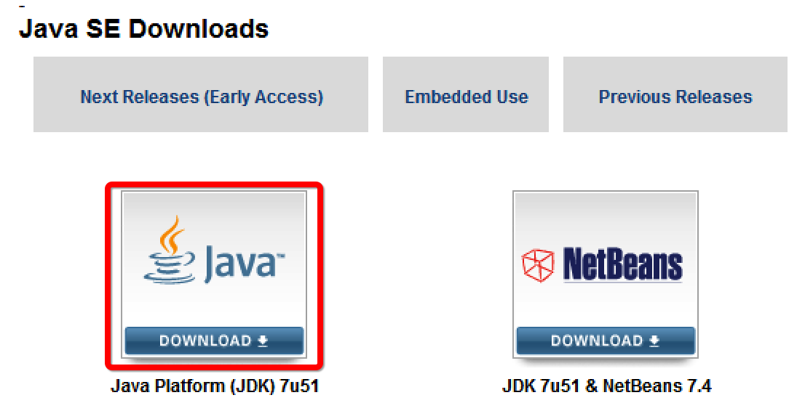

Click the big icon for Java only (We don’t need NetBeans), and then please select the Windows installer (I think yours are 64 Bit):

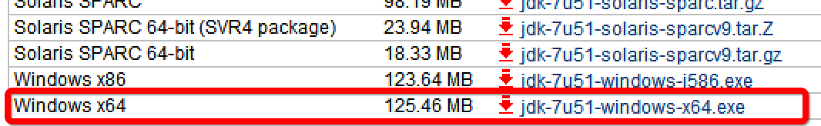

Then please run the exe and follow the instructions. **Please install this first**; otherwise, no software mentioned below can work.

* 1. Tomcat

Go to http://tomcat.apache.org/download-70.cgi to download Tomcat

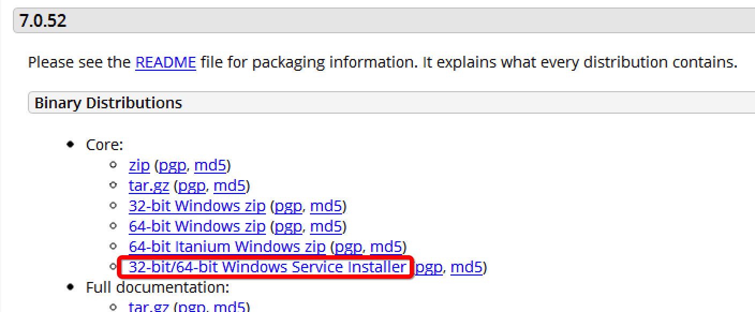

We are to use the version 7.0.52. Please scroll down the page, and click the Windows service installer (Shown above).

Then please run the exe and select Full installation, then follow its instructions.

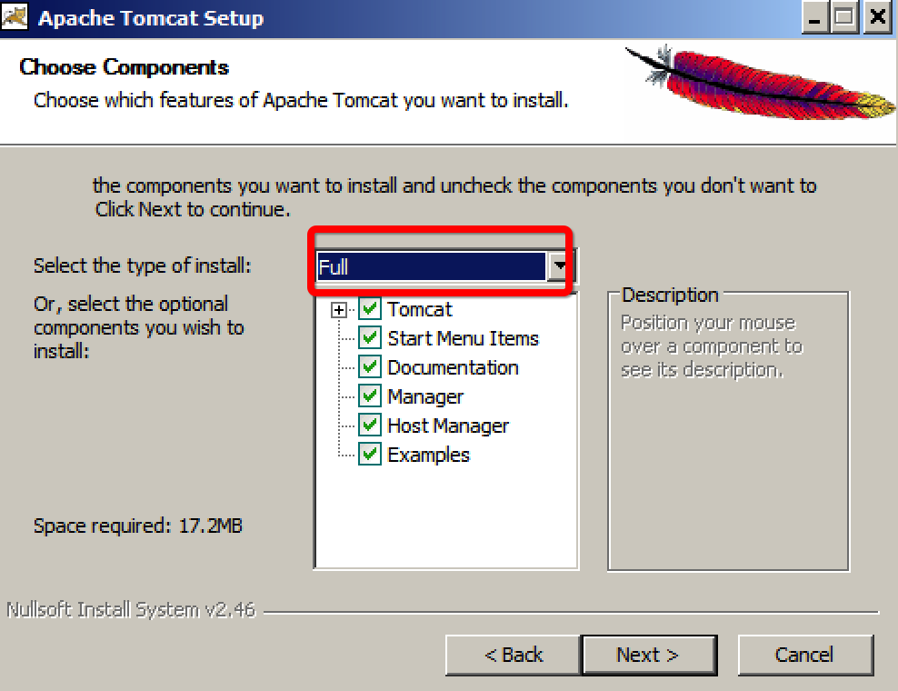

Select Run Tomcat at the end of this installation. To verify your installation, please open browser to key in: <http://localhost:8080/>. By right, you will see the following page:

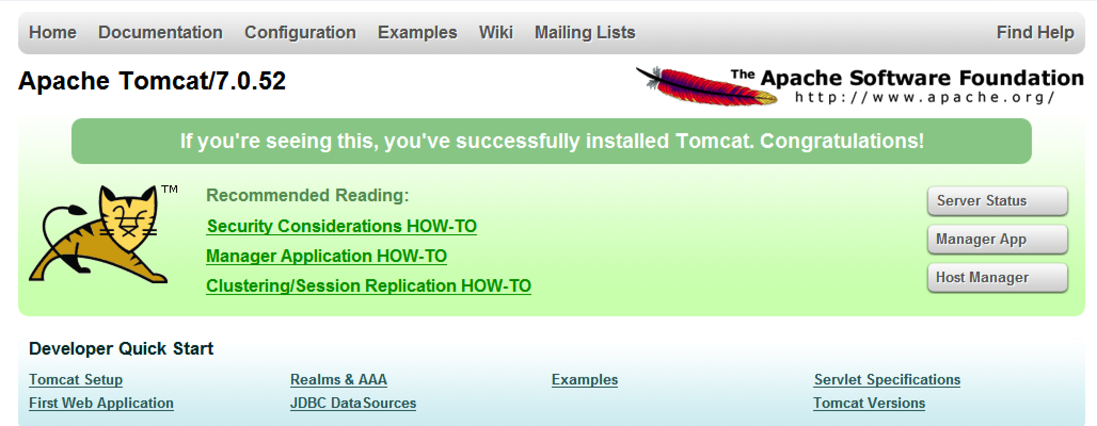

This means your cat is running ☺

* 1. MySQL

Go to <http://dev.mysql.com/downloads/windows/installer/> to download MySQL.

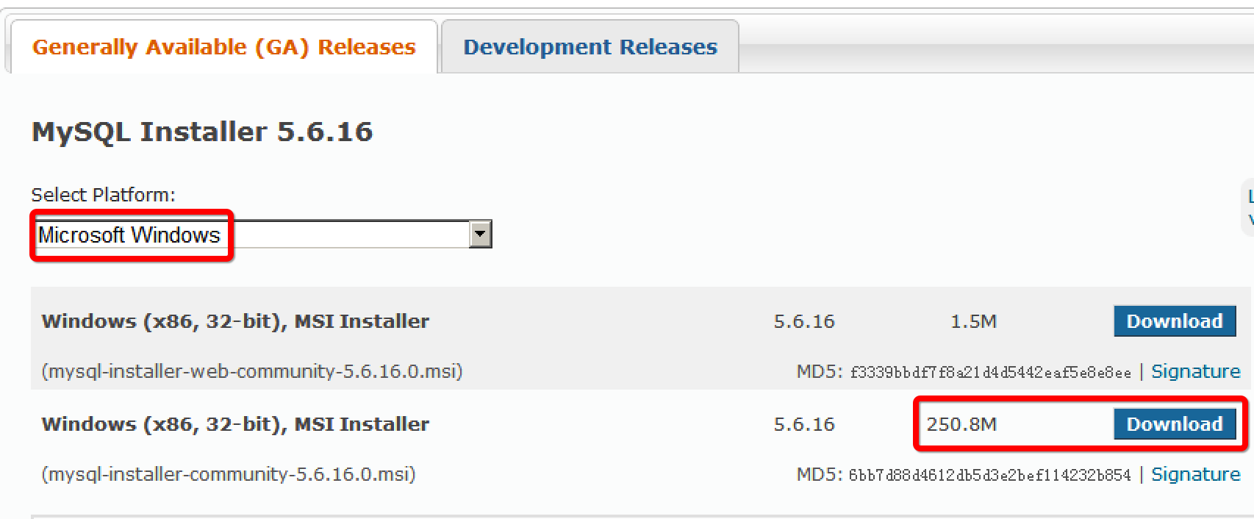

This official site requires a registered Oracle user id (free). But if you don’t wanna register that, please Google MySQL installer 5.6.16 then you will probably find it somewhere else…

However, please make sure it is the version around 250M, which means it includes the MySQL Workbench.

* 1. Eclipse

Go to <http://www.eclipse.org/downloads/> download Eclipse.

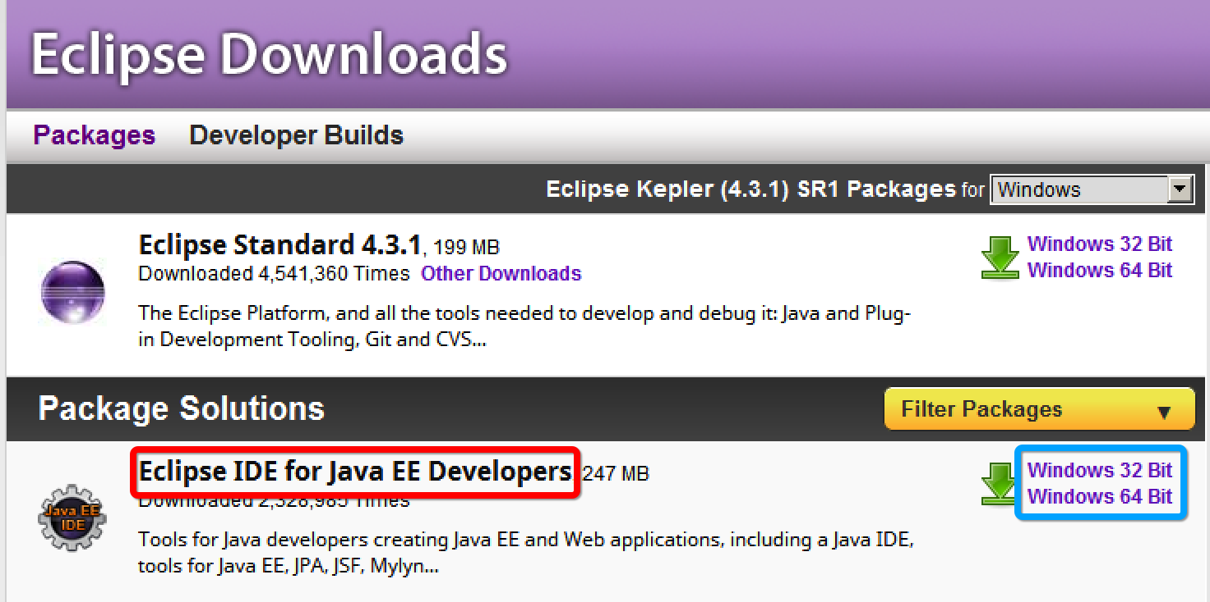

Select the Java EE Developer enhanced version as indicated above. Please select the right Windows platform.

Then please just unzip the compressed file (to a comfortable place), this is also called Eclipse_Home.

* + 1. EGit

Start eclipse.exe from the unzipped folder, and install Github plugin by add new software sites:

EGit: <http://download.eclipse.org/egit/updates>

Select all components then agree the license agreement and install them.

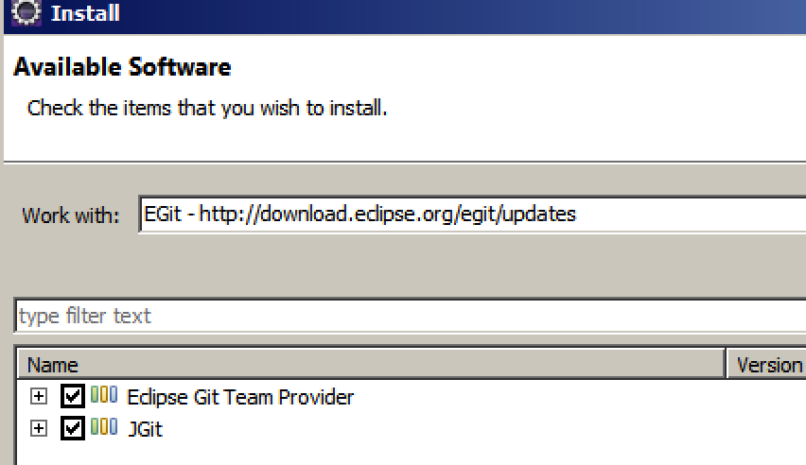

* + 1. Sysdeo Tomcat Plugin

I’ve uploaded the tomcatPluginV33.zip file to our GitHub, please download it from :

<http://aaaaaa>

Unzip this file and you will get a folder named: com.sysdeo.eclipse.tomcat_3.3.0. Copy this folder to you Eclipse_Home/dropins, i.e. the folder where you “comfortably” put your eclipse. For example, my eclipse is placed at: c:\eclipse, then I copy this folder to c:\eclipse\dropins, like below:

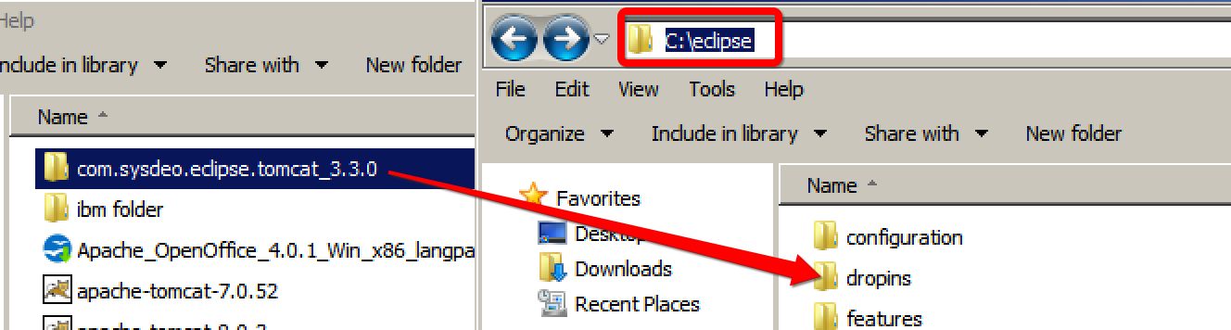

Restart your Eclipse, you will see Tomcat icons on the tool bar:

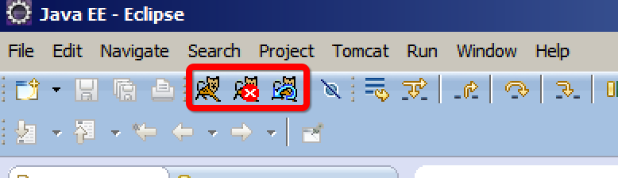

If not, please restart your eclipse with parameter **–clean**.

* 1. Github Client (Optional)

Go to <http://windows.github.com/> to download Github win client

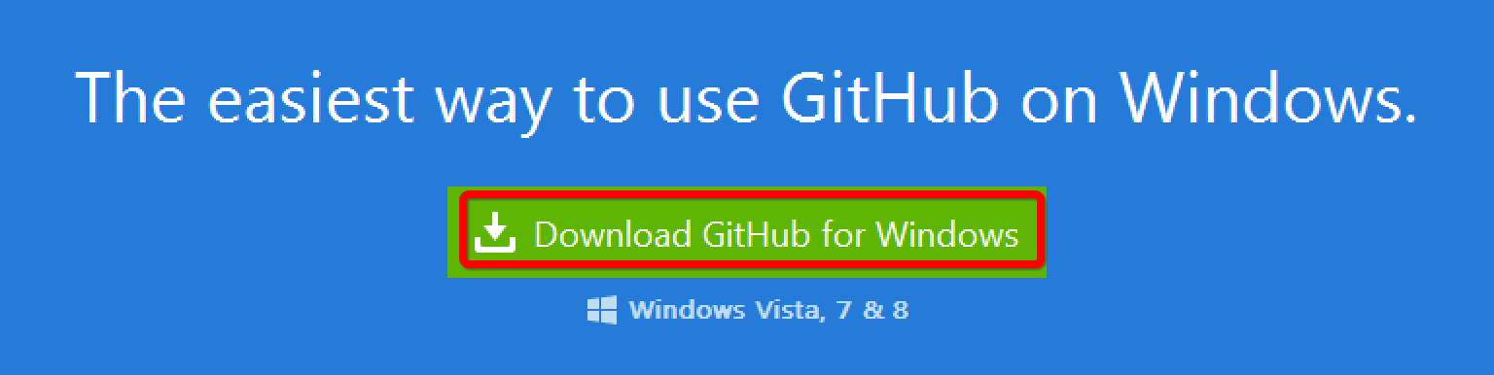

The MS .Net Framework may be required, please say yes and wait.

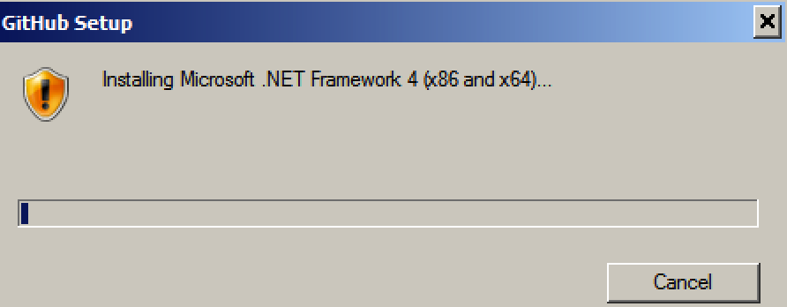

This may takes some time…

As we are using the plugin in Eclipse, this software is optional to provider extra convenience (or trouble ☺).